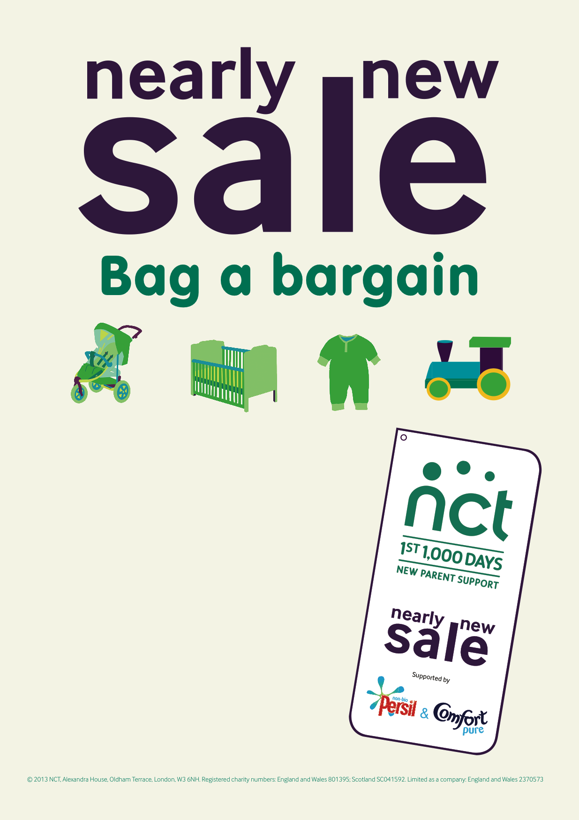

**Saturday 4th Oct, 2014**

**1:15pm- 3pm Queen Mary’s College**

**Cliddesden Road, Basingstoke, RG21 3HF**

**(15mins earlier for NCT members with membership card)**

**Entrance by £1 donation** (in aid of NCT Charity)

Please note that in the interest of Health & Safety, buyers will not be able to enter the sale with any kind of wheeled conveyance (e.g. pram, pushchair) except in special circumstances

Free Car Parking available

If you would like to sell or volunteer, check the website **http://www.nct.org.uk/branches/basingstoke/nearly-new-sales or email us:** nearlynewsale@basingstokenct.org.uk

We welcome new NCT and Non- NCT members for selling and volunteering.