National Childbirth Trust
Redbridge and District Branch
Nearly New Sale

Saturday, 23 March 2013
Christchurch Hall, Wanstead Place
E11 2SW

Dear Potential Seller:

Time to get ready for the Spring 2013 Nearly New Sale!

The enclosed seller’s guide contains important information relating to pre-sale requirements, the quality of items for sale, Terms and Conditions and a registration form. Please read these documents carefully and make sure you are familiar with them.

In addition to the guidelines, below are some key points we would like to draw your attention to;

Sale Schedule:
Below are details of key timings on the day of the sale. It is especially important that you drop your items off promptly and that you are able to pick up any unsold items at the end of the day.

9:00-9:30 Sellers drop off sale items - Sale Helpers will be displaying your items so sellers will be required to register at the front door and drop off their goods. This is to help ensure the security of your sale items. It also has the added benefit of making life much easier for you!
10:45-11:00 NCT members and Sellers entrance (with membership card or sellers ID)
11:00-12:30 General entrance
13:15-13:45 Sellers pick up sale items - Please also be aware that we will be displaying unsold items and lost property items that have lost their labels at the door when you return to collect your goods, please view these!

Quality of Items:
In particular, please review the section on "Rules for Display - Quality". During set up, we try to weed out items that are obviously dirty, worn or in poor condition, but time is limited so we cannot inspect each item thoroughly. From previous sales, we have received buyer complaints of toys that are crusted with old food and dust or have broken/missing pieces (which have not been noted on the item), and clothing with significant stains that have been hidden behind other items. As on eBay, some buyers are happy to buy second hand items in less-than-new condition, as long as they are made aware of the flaws from the outset. Buyers come to our sales with an expectation built upon years of NCT reputation for good quality nearly-new items. Many thanks for your help in maintaining our reputation!

Bulky Items:
We are reserving an area for large furniture items like highchairs, pushchairs, cots etc. Space is restricted so if you are interested in selling such an item please inform us before hand by email to nct_redbridge_nns@yahoo.co.uk with “large item” in the title. If the item is not assembled on the day of the sale due to its size, we strongly suggest that a picture is attached so sellers can see what the item looks like set up.

Prohibited Items:
A list of prohibited items can be found in the guidelines and while you cannot sell these at the sale these items can be posted as an ad on the For Sale board. There is no additional fee or commission for posting an ad. Please send your A6 ad (105 × 148mm) to Dione Le Tissier for receipt by Friday 15th March. Any sales resulting from this board are purely between the buyer and seller and are not the responsibility of the NCT.

Contract and Registration Deposit:
Please send your completed contract (page 7) and registration deposit to the address below by Friday 22nd February by the latest. We limit the number of sellers to the first 75 who return the enclosed Seller’s Contract and Registration Deposit so please send it back as quickly as possible. If you are selected, you will receive a letter confirming your seller’s place and your requested sale item labels.

Finally, we would ask you to “spread the word” about the sale to as many people as you can. We need sellers, as well as buyers. We would greatly appreciate if you would post the flyers included at the back of the pack at your local school, play group, nursery, surgery, church, shop, etc.

Thank you for your participation and support. We look forward to seeing you at the sale.
We would welcome more sale helpers, so please tick the box on the seller’s contract page if you can help out and one of us will get in touch with you.

Questions? Contact the NNS team by emailing nct_redbridge_nns@yahoo.co.uk

Yours sincerely,
Send your contract and deposit to:
Dione Le Tissier (NNS), 2 Grove Mansions,
55 High Street, Wanstead, E11 2AE

Questions?
Email: nct_redbridge_nns@yahoo.co.uk

Nearly New Sale (NNS) Team

NCT REDBRIDGE & DISTRICT BRANCH
NEARLY NEW SALE – TERMS & CONDITIONS

Saturday, 23 March 2013 – Christchurch Hall, Wanstead, E11 2SW

Questions? Contact the NNS team by emailing nct_redbridge_nns@yahoo.co.uk

GENERAL INFORMATION
- Maximum 75 Sellers – First 75 applicants received by Friday 22nd February 2013.
- Seller’s Contract (page 7) – Please complete and send to Dione Le Tissier, 2 Grove Mansions, 55 High Street, Wanstead, E11 2AE.
- Registration Deposit – Please include £5 cheque with contract (no cash please) payable to “NCT Redbridge & District”
- Administrative Fee – £2.50 to be taken from sellers proceeds (don’t include in deposit); includes 40 labels
- Additional Labels – additional labels can be purchased for £1 per 40 labels + a 50p postage & packaging fee if sent separately. (e.g. If you request 40 extra labels with your initial allotment, you will be charged £1. If you make a subsequent request for 40 extra labels, you will be charged £1.50)
- Confirmation – Once we receive your contract and Registration Deposit, you will be sent a confirmation letter and your labels.

MONIES
- Sellers will receive 70% of the selling price – 30% is donated to the NCT.
- There is now a maximum of £30 donation to the NCT per item (see notes about expensive items below).
- Registration Deposit – refunded by post with your proceeds cheque provided you have sorted and collected your unsold items.
- Cheques for proceeds from the sale (less the £2.50 administrative fee, 30% donation and fee for any additional labels) will be posted to sellers after the sale

ACCEPTED ITEMS | PROHIBITED ITEMS
- Baby/Children’s Clothes (up to age 6)  - Maternity Clothes  - Baby Equipment  - Toys  - Baby bouncers/walkers as long as full instructions are included  - Breast Pumps - Brand new manual or battery powered (not mains electric)  - Prams & buggies – these must have a permanent label (usually on the frame or seat cover) stating compliance with British Standard 7409 or EN1888 (see ‘safety’ below)  - Books/Videos/Tapes/CDs/DVDs for:  - Children  - Parenting  - Pregnancy | - Recalled Items – please ask for details if unsure  - Bag Style baby slings  - Car seats, car booster seats ‘Isofix’ bases or car seats from travel systems  - Riding hats/Crash helmets  - Bottles, Baby food and formula milk  - Mattresses (unless fully covered with a waterproof covering e.g. PVC – please ask for details)  - Second Hand breast pumps  - Children’s clothing with drawstring around neck  NOTE: Ads for large or prohibited items can be posted on the For Sale board. See below for more information. If you are unsure of the suitability of an item, ore require further information please contact the NNS team.
NOTE: Items are placed for sale at your own risk. Whilst every reasonable care will be taken with goods left for sale, the NCT cannot be held responsible for any items lost, damaged, stolen or any monetary discrepancies that may arise.

PRICING
- Pricing – The minimum item price is 50p, and prices should be divisible by 50p, so £1, £1.50, £2, etc.
TIP - If you have several low value items, combine them in a plastic bag (a bundle) to make one higher value item.
- Expensive Items – For security purposes, you are required to inform us upon registration at the door if you intend to sell any item for £50 or more. You must provide a sheet of paper with full description of the item and a list of each component or accessory included. (e.g. pushchair, rain cover, cosy toes, etc.)
TIP – Expensive items may not always be bought. If you really want an item to sell, price it accordingly.
- Price Reductions – Altered labels will not be processed at the tills. If you need to alter a price during the sale, ask the NCT Room Monitor to re-label the item. This is to safeguard your property and ensure the true seller is making the reduction.
- Donations – If you wish to donate items to the NCT, mark label with item price and “NCT”. WE WILL NOT ACCEPT UNSOLD ITEMS (AND NOT COLLECTED) AS A DONATION. Such behaviour will mean the seller will forfeit their deposit and will not be allowed to sell again.

Sample Pricing (range for clothing depends on age/size of item and style)
Shorts/Tshirt 50p-£2.50 Sleep bags £1-8 Sit-and-ride £3-6
Blouse/shirt 50p-£2.50 Maternity trousers £4-12 Change mat £1
Dress/Trousers £1-4 Baby gym £5-10 High chair £20+
Cardigan £1.50-3 Activity centre £1.50-5 Cot (no mattress) £15+
Coat/Jacket £3-6 Jigsaws 50p-£3 Single pushchair £15+
Jumper £1.50-3 Soft toys 50p-£2 with accessories £20+
Swimsuit £1-3 Books (1 lg or bundled) 50p-£1 Double pushchair £30+
Slippers/Wellies £1-3 Video/CD £2-3 Travel cot £15+

We would suggest that if an item is in MINT condition with it’s original packaging, then you could ask up to a third of the original new price.

FOR SALE BOARD
Ads for large/prohibited items can be posted on the For Sale board, which will be displayed initially at the sale entrance and, later during the sale, will be moved to the paying queue. Potential buyers will contact you directly, so don’t forget your contact details. Digital images and a full description are also helpful. Send your A6 (quarter of A4; 105 × 148mm) ad to Dione Le Tissier (NNS) 2 Grove Mansions, 55 High Street, Wanstead, E11 2AE for receipt by Friday 16th March.

RULES FOR DISPLAY
Labelling
- 2 Part Labels – Items must be clearly labelled on both sections of labels provided. We will reject all items bearing old labels. Failure to follow labelling instructions may result in your items not being displayed for sale.
- Labels must include:
- Seller number (essential for adding up your sales total)
- Price
- Description
- Age/size (e.g. Boys trousers age 12-18 mo)
TIP – Additional information can be like a personal recommendation and help sell an item. If you found a piece of equipment particularly useful, share your experience with shoppers by including your notes on an additional piece of paper securely taped to the packaging.
- Attaching Labels – Attach labels securely at the top of the label. Use safety pins, string or thread on clothes, soft toys and fabric items. Use sticky tape for hard items such as toys or equipment and items in plastic bags. Attach labels in a prominent position on the item (not the hanger). But please do not cover the perforation on the labels with tape, as one half is removed at the till!
- Multiple Part Items – If an item includes two or more parts, do label each part but make sure to indicate which part it is and how many parts in total. For example, “2 of 4 parts”. This will help ensure the parts of your item are sold as a whole and not duplicated in the accounting process.

Packaging & Sorting
- All clothes, both for children and maternity, including sleep bags must be on hangers or sold as a bundle in a clear plastic bag. Clothes not as stated will NOT BE DISPLAYED. Children’s shoes will still be accepted.
- Please deliver clothing items sorted by sex and in the following size groups: 0-3 mo, 3-6 mo, 6-9 mo, 9-12 mo, 1-2 yrs, 2-3 yrs, 3-4yrs 4-5 yrs, 5-6 yrs, maternity. Note that the maximum age for clothes is age 6. Unsorted clothing items may not be displayed if we do not have time to do the sorting for you.
- If you have a number of low cost items of clothing e.g. same sized sleepsuits, vests or t-shirts you may be more likely to sell the items if you package them in a bundle inside a clear plastic bag. Make sure you clearly label the bag with size and number as well as other useful information e.g. brand

Clothing Maximum
- You will be permitted to sell a maximum of 30 clothing items. If you submit more than 30 items, we will use our own discretion when selecting which 30 items to display. A bundle in a clear plastic bag will count as one item. There is no limit on toys, equipment, etc.
TIP – Group clothing in sets or outfits. Name brands sell best, so including a NEXT or GAP item with other no-name items will help the latter sell. Grouping will also help you get the most out of the Clothing Maximum, as each set or outfit is counted as a single item. For example, Item One = one set of three shirts for £2.50; Item Two = one outfit of a shirt, trousers and cardigan for £6.
TIP – Seasonal items sell best in the correct season.
TIP – Select the best quality baby clothing. We generally have an excess of 0-12 month garments.
TIP – Supermarkets and retailers such as Primark sell baby clothes cheaply. The sample pricing above may not result in sales unless your items are very good quality and of a good brand. A lower price may ensure a sale

Quality
- As New – All items submitted to the sale must be of nearly new quality. This is not a jumble sale.
- CLOTHING MUST BE CLEAN! No stains, no damage, no missing buttons or faulty zips.
- All Other Items – Clean and in full working order with no signs of major wear and tear and all advertised items included. If a minor part is missing or a minor feature is not working, please note it on a separate label or piece of paper. All items will be quality checked and those not meeting our standards will be rejected from the sale.
TIP – Ensure toys with multiple parts are secured to the main body of the toy or else parts may be lost. (e.g. in a sealed plastic bag)
- Misrepresentation – Any seller who misrepresents an item for sale will be excluded from future sales.
(e.g. If a book’s binding or pages are torn, it must be labelled as such.)
TIP – Collections command a higher price. Small books, baby toys, etc. may be tied/bagged and sold as a group. In order to ensure a sale, try including a desirable item with some more common items. (e.g. A set of stacking cups plus a couple of rattles.)
TIP – If you have items which didn’t sell in a previous sale, give some thought to why and whether it’s worth submitting them again, rather than just throwing everything in again sale after sale. For example, spring and summer clothing sells better in March than in October. However, a 10 year old cot probably doesn’t meet up to the expectations set by current product features.

Safety
- Baby Equipment
- All baby equipment priced at £50 or greater must include a separate label or piece of paper with seller’s full contact details.
- Wheeled child conveyances regulations – From 1 January 1999 major changes in the law relating to the sale of both new and second hand “wheeled child conveyances” came into force.
- The term “wheeled child conveyances” refers to all wheeled vehicles designed to carry one or two babies or infants, but does not apply to transporters for carry cots, toys or vehicles enabling children to move themselves about.
- “Wheeled child conveyances” must have a permanent label (usually on the frame or seat cover) stating compliance with British Standard 7409 or EN1888. The standard lays down requirements regarding the construction, performance and labelling for prams and pushchairs. Machines must also have a label headed ‘Carelessness Causes Fire’ which indicates that the fabric complies with flammability requirements
- A permanent notice on the vehicle must state: Children should be harnessed in at all times and should never be left unattended. The child should be clear of moving parts while making adjustments. This vehicle requires regular maintenance by the user. Overloading, incorrect folding and the use of non-approved accessories may damage or break this vehicle. Read the instructions.
- Instructions in English must be supplied with each vehicle. These are to be headed: IMPORTANT, KEEP FOR FUTURE REFERENCE and must include instructions relating to operation, assembly, use and maintenance.
- In addition, prams and buggies should be checked for the following:
- Brakes – these should work and be able to stop a loaded machine on a slope. The tyres should also be examined as these can affect the performance of brakes
- Locking Devices – there should be two locking devices on each machine so that when the main lock is released, the secondary lock prevents the frame from collapsing
- Harness – a secure safety harness must be fitted
- General – look for damage from wear and tear. Check to ensure that a child’s fingers cannot be caught anywhere. The frame should be secure and free from sharp edges or exposed parts
- Stair gates, fireguards, barriers and bed guards must have all correct fittings, and have no gaps where it would be possible for a baby to get his/her head stuck.
- Safety Standards – All toys should bear the CE or lion mark to show they meet the approved safety standard. Please make sure your items are suitable for children to use and in good repair, with no sharp edges, peeling paint, seams coming apart or loose attachments.
- Instructions – If the manufacturer’s instructions are not included, it must be labelled as such.
TIP – Equipment with instructions sell better. If you’ve lost the instructions, try checking the manufacturer’s website for printable instructions or usage tips. Include these with the item.

DROPPING OFF – 9:00-9:30
For security reasons:
- Registration – Collect your seller name tag upon arrival. Notify us how many bags or containers of sale items you are dropping off. Provide information on any expensive items.
- Drop Off at door – NCT staff will set up your sale items in the hall. Label any bags or other containers you wish to have returned to you with your name and sellers number.

NOTE: Sellers will not have access to the hall during set up time. Sellers wishing to shop during the sale can queue in the Members line provided they are still wearing their name tag. Entrance fee is £1/family.
NOTE: Only NCT committee members and registered helpers will be permitted in the hall outside of sale hours.

CLEAN UP – 13:15-13:45
- Pick Up – Your remaining sale items will be collected for you to pick up. Sellers must retrieve any unsold items during clean up or forfeit their deposit.
- Remaining Items – Uncollected items left in the hall after 13:45 will be disposed of after three weeks. In the event that a label comes off an item, the item will be removed from the sale and kept for three weeks. If, after receiving your proceeds cheque, you believe you are missing an item, please contact the NNS team ASAP.

SALE HELPERS
If you would like a chance to shop early or would simply like to help at the sale, please indicate this on your registration form. We also need help before and after the day of the sale. Only registered helpers will be permitted to help on the day. There will be a planning meeting for registered helpers before the sale – date and time to be arranged.

DISCLAIMER
The Sale is staffed by volunteers. Although reasonable efforts will be made, we cannot guarantee to prevent any loss or damage to goods. If any of your goods cannot be found and we have no label to verify their sale, the branch accepts no responsibility for them and no compensatory payment will be made. The branch will not accept responsibility for any alleged damage to items.

NCT REDBRIDGE & DISTRICT BRANCH
NEARLY NEW SALE – SELLER’S CONTRACT

Saturday, 23 March 2013 – Christchurch Hall, Wanstead Place, E11 2SW

Please complete and return this Seller’s Contract along with your £5 Registration Deposit cheque (NCT Redbridge & District) to:

Dione Le Tissier (NNS) Questions ???
2 Grove Mansions Email: nct_redbridge_nns@yahoo.co.uk
55 High Street
Wanstead
E11 2AE

I, ________________________________ (the seller), will participate in the NCT Redbridge and District Nearly New Sale on Saturday, 23 March 2013 from 11:00-12:30 and agree to the following:

- I will deliver my sale goods, labelled and sorted according to the guidelines, between 9-9:30.
- If I wish to shop early, I will attend the planning meeting and help with the sale.
- I will retrieve any unsold items at the end of the sale between 13:15-13:45.
- My Registration Deposit Cheque will be returned to me with my sale proceeds. I will forfeit my Registration Deposit should my unsold items not be collected or I fail to attend.
- Any items left by me in the hall after 13:45 will be disposed of after four weeks.
- A cheque representing the proceeds (less the £2.50 Administrative Fee and 30% donation to the NCT) will be posted to me approximately a month after the sale.

“I have read the NCT Nearly New Sale Terms and Conditions. I wish to submit goods for sale at the Nearly New Sale on 23 March 2013. I agree that the Redbridge & District NCT accept no responsibility for loss or damage which may occur.”

Signature: Date:
Name: Email:
Address:

Postcode:
Mobile phone : Evening phone:
40 labels will be provided in your confirmation pack.
Additional labels can be purchased for £1p per 40 labels (+ a 50p postage & packing fee if sent separately).

Please send me the following TOTAL quantity of labels (include your initial 40 labels in your count):

40 80 120 160

I am enclosing an A6 (105 × 148mm) ad for the For Sale board.

I will be submitting an A6 (105 × 148mm) ad for the For Sale board by Friday 16th March

Please check this box if you wish to help out at the sale and are interested in attending the Helpers Meeting – this will be on a weeknight evening the week before the sale.

Large Items being sold ____________________________________________________________

Note: Only send your deposit cheque for £5. Your admin and extra label fees will be deducted from your proceeds.

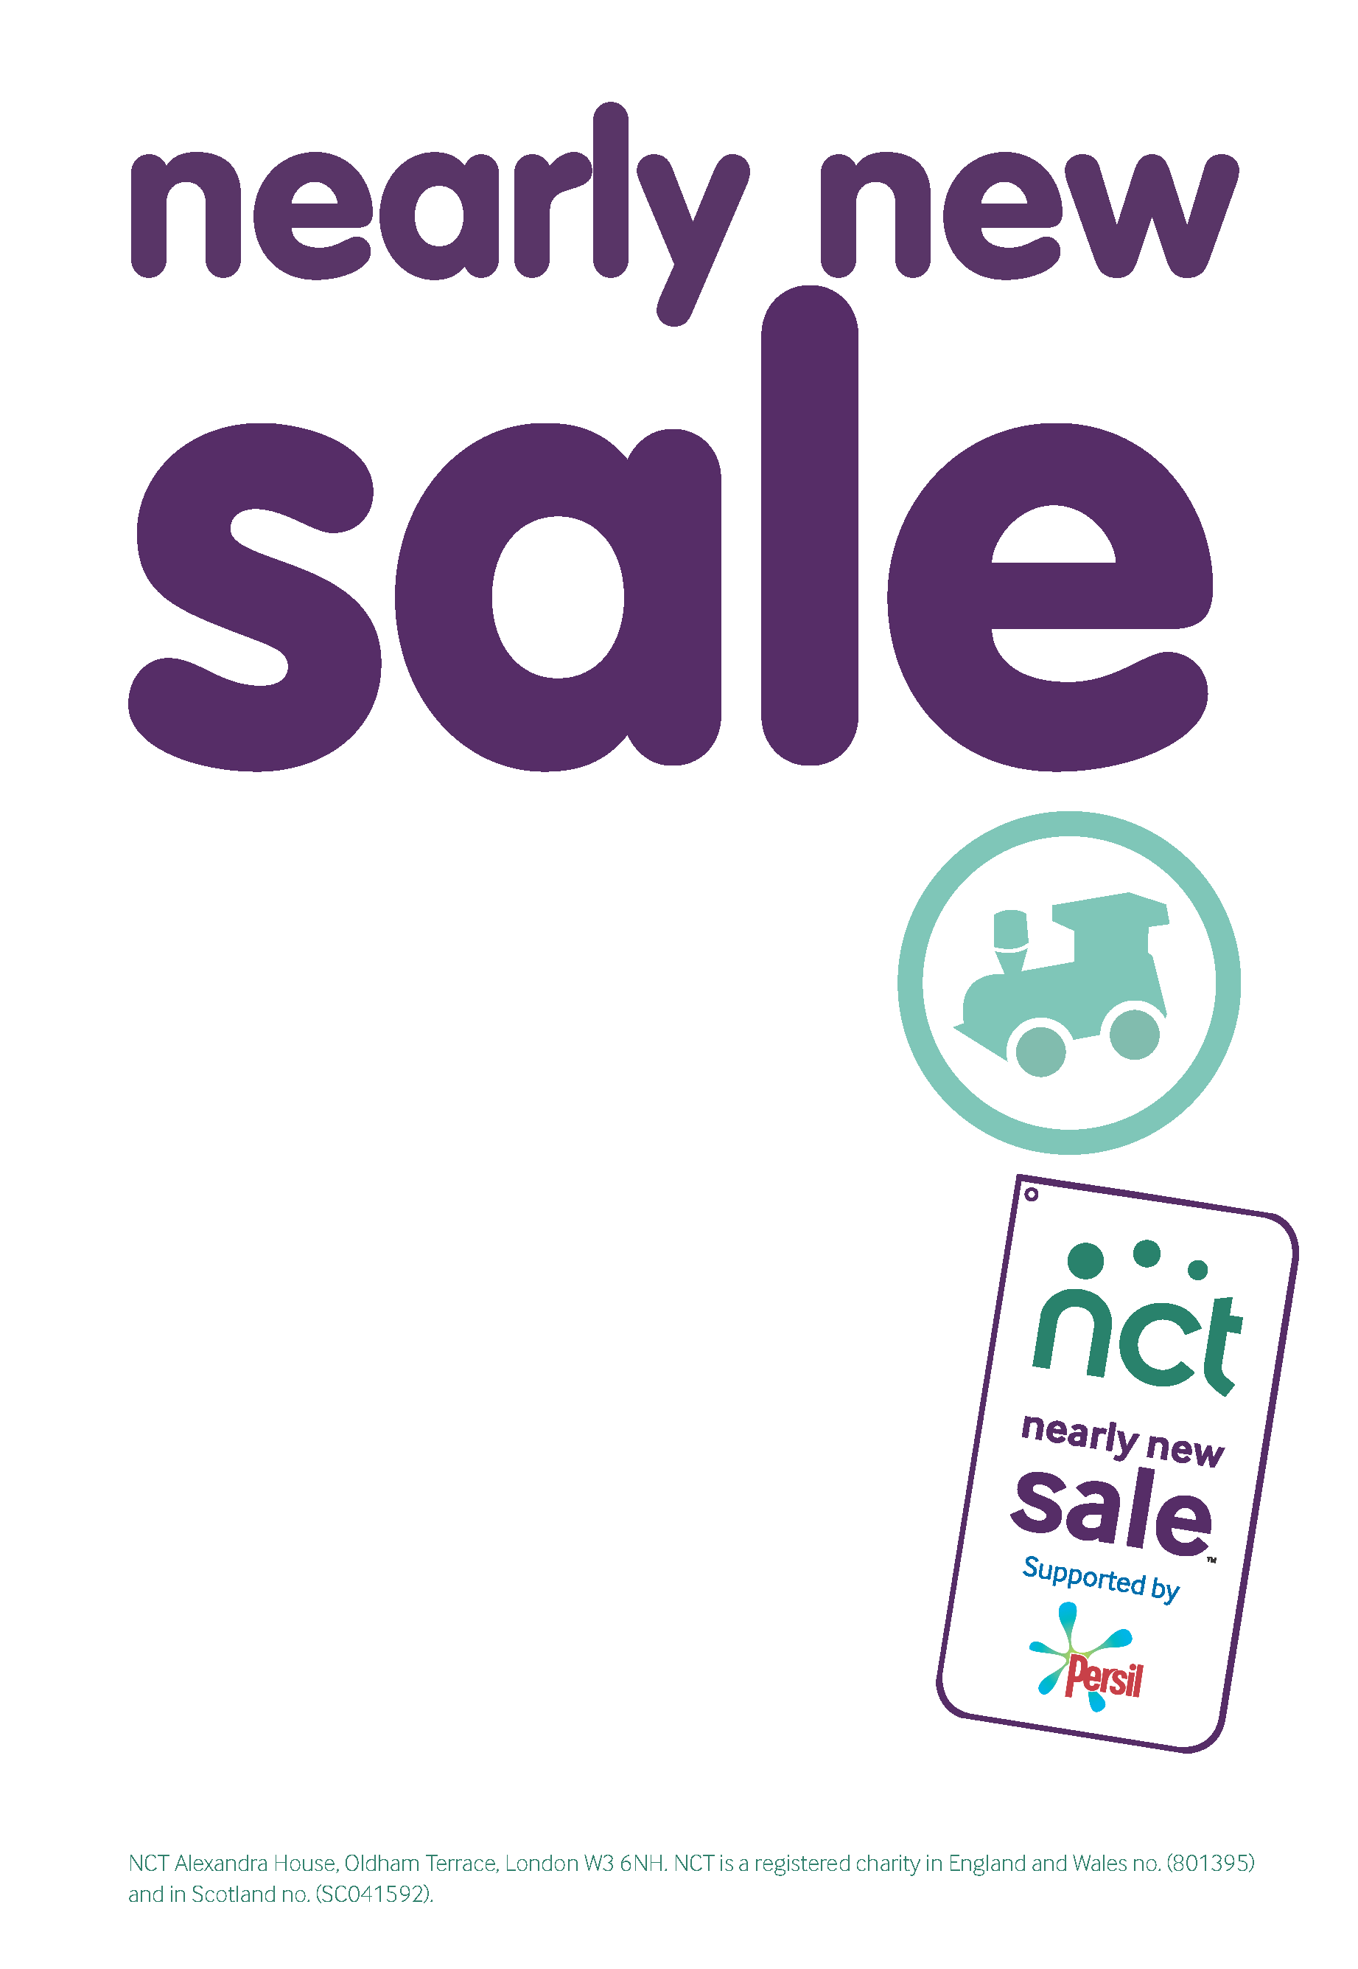

BE A SELLER AT THE NEXT NEARLY NEW SALE
ON 23rd March 2013

Sell your nearly new toys & books, baby equipment, baby furniture bedding, baby clothes, children's clothes and maternity clothes

To register to sell email: nct_redbridge_nns@yahoo.co.uk
www.nct.org.uk/redbridge

27th October 2012
Top quality baby and
children’s clothes, toys
and equipment at
bargain prices.

Saturday 23rd March 2013 11:00am - 12:30pm
Christchurch Hall, Wanstead Place, E11 2SW

Christ Church Hall, Wanstead Place, E11 2SW
Admission price £1 (in aid of NCT Charity)
NCT members entrance 10:45am with membership card

Café also open. All buyers welcome. Sorry, no pushchairs or
prams allowed in the hall.

For more details email: nct_redbridge_nns@yahoo.co.uk
www.nct.org.uk/redbridge

27 October 2012

