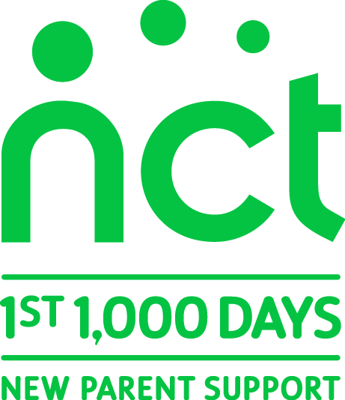

PRESS RELEASE 7 January 2014
Peterborough NCT Branch fights to save Children’s Centres, responding to Peterborough City Council’s proposed cuts
Peterborough NCT volunteers call for local Children’s Centres to be saved as Peterborough City Council (PCC) proposes radical cuts to local support services for families.
Attached is the NCT Branch’s response to PCC’s Consultation on Children’s Centres, which it proposes to implement from 1 April 2014. The response deadline is Wednesday 8 January 2014.

SUMMARY: of the 5 areas in our attached response:
1. We know PCC needs to save money, but it can choose where to save it and how to spend what it has.
2. We have problems with the Consultation document, such as:
- It’s not thought through from a user perspective e.g. what’s needed, how to access it
- It hasn’t learned from experience e.g. Surestart; and it’s not futureproof e.g. new housing plans
3. We know something about what’s needed and what Children’s Centres have been doing:
- Children’s well-being* relates to Connecting, Being Active, Keeping Learning, Taking Notice and Creativity/ Imagination/ Play: all addressed by Children’s Centres and Libraries (*source: Children’s Society Good Childhood Index, updated 2013)
- All families can benefit from Children’s Centres support e.g. parenting courses, facilitating community cohesion, breastfeeding support; as well as targeted support for domestic abuse sufferers, social contact to reduce post-natal depression...
4. An example of Peterborough parents’ needs currently met by Children’s Centres that would be cut:
- Free, open to all drop-ins for advice and support. This can: help children maintain relationships with both parents, prevent family difficulties becoming serious, etc. Early detection/ prevention reduces the impact of health and other inequalities/ deprivation on children... and long term costs to PCC.
5. Our alternative proposals and ideas therefore include:
- PCC should have a joined up approach with other drop-in services for parents of children under 5 (Libraries, Health professionals, other activities e.g. breastfeeding support) and only close Children’s Centres where buildings are needed (e.g. for new school classrooms) and where adequate other local sustainable safe supportive spaces are available for families at least every weekday.
Beki Sellick, volunteer Parent Support Coordinator from NCT Peterborough says “Peterborough parents tell us they need somewhere they can easily reach to drop into anytime, for social and emotional support as well as advice and reassurance for themselves and about their children’s development.”

For more information please contact: Beki Sellick, volunteer Parent Support Coordinator, NCT Peterborough
on 01733 897795 or 07719 685788 or RLSELLICK@HOTMAIL.COM
- ENDS -
Notes to Editors
About NCT: NCT is the UK’s largest parent charity. Each year the charity supports millions of parents through their First 1,000 Days, offering expert information and trusted practical and emotional support through its website, helpline, the nationwide network of over 300 local branches, antenatal and postnatal classes, breastfeeding counselling and peer support schemes. For more info call NCT on 0300 3300770 or visit www.nct.org.uk.

