Case study Walsall Manor Hospital April-2013 to June 2013

Who we worked with
Walsall Healthcare NHS Trust, Walsall Manor Hospital, Walsall West Midlands.
NCT delivered
Pregnancy Birth and Beyond’ Refresher Course for multiprimis and Young Parents courses.
Key findings
- Respondents found the courses to be ‘excellent’ (80%) or ‘very good’ (20%).
- Respondents across all courses felt the course had provided them with more confidence about antenatal topics in general and life with a new baby than they had before the course (79%).
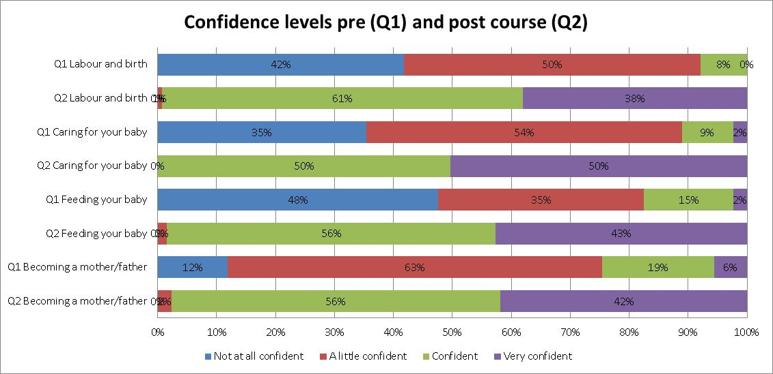
What they said about the courses
“I liked practising nappy changing and bathing. It’s good to have a go before doing it for real”
“The class was fun and the teacher was nice. I could ask her any question I wanted to and she didn’t look down at me.”
“I might think about breastfeeding now.”
“I liked the small group. We all had lots of attention and the class went at our speed.”

Getting started
Setting up parent education courses with NCT is simple. Just email us with your contact details and one of our advisers will get in touch.
commissionedservices@nct.org.uk

