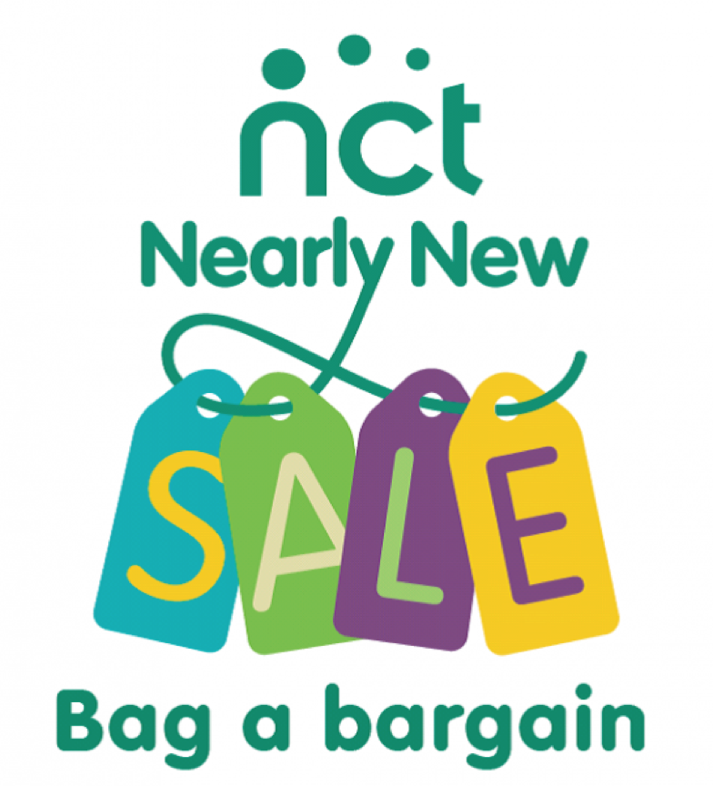

NCT Nearly New Sale is a great way of raising awareness and funds for the work of the charity.

Goods at sales
We sell maternity goods, parenting goods, baby and children’s clothes 0-10 years, toys, books and equipment up to age 10.

There are a few items we cannot sell, and some restrictions. These are listed in our Nearly New Sale Principles on our national website. All sellers MUST read and abide by our Nearly New Sale Principles.

https://www.nct.org.uk/get-involved/fundraising-activities/nct-nearly-new-sales/sell-nearly-new-sales

Hints and Tips
Clothing tends to sell better if it is in the current season. E.g. winter coats do not always sell well in April/May.

This is a Nearly New Sale - if items are in poor condition they will put buyers off and we reserve the right to remove them from the Sale.

Please make sure items are clean and stain free.

How much money can I keep?

NCT takes a commission which goes towards the charity’s national work and also to support local mums and dads, preparing them for birth and early parenthood. Volunteering in our sales will help the seller to keep more of the sale price for themselves. The details of the percentage of the commission and the discretions for volunteering are to be confirmed.

How should I prepare & price my items?
- Please price items in multiples of 50p. (£1.00, £1.50, £2.00 etc.).
- The minimum price is 50p.
- Pricing is up to you but bear in mind that if you price things highly they may not sell. Many high street outlets are selling clothing very cheaply now, even quality brands, so price your items competitively.
- Most sellers use the following guidelines:
  - Sleepsuits – 50p to £1,
  - Cardigan/Jumpers - £1 to £3
  - Coats/Jackets - £2 to £5,
  - Dresses - £2 to £5
  - Trousers/Jeans - £1 to £4,
  - Shoes/Wellies - £1 to £3
  - Highchairs £5 upwards,
  - Stairgates £5 upwards
  - Children’s bikes £5 upwards,
  - Small slide £5

How should I label my items?
We use a two part label system to increase accuracy and speed up payment at the tills. At the checkout, half the label will be cut off and retained and half will remain attached to the item. Please use the labels provided to mark up your goods before the sale.
Both halves of the label should display the same information. Please attach just one half of the label to your items - the other half needs to be easily removed at the tills. Labels need to be attached securely to items (not to hangars) using safety pins/tape/string/tag gun. Please ensure the item is not damaged by the label attachment e.g. use masking tape for books.
Please make sure the labels are not inside or sealed in bags and only taped on the top half.
For security reasons we do not sell items without a label attached. So no label = no sale and the item can only be returned to you if you pick it from the “lost labels” table at the end of the sale. We do not allow altered labels through the till as we cannot be sure if a buyer has altered the label – so if you make a mistake – use a new label.
e.g.
This side is
attached to the item
Seller: 085 | Seller: 085
 | This side is removed and retained at the till
Item: Boys jeans | Item: Boys jeans
Age/Size: 2-3yrs | Age  /Size: 2-3yrs
Price: £3 | Price: £3

How should I package my items?
- Bring your items in cardboard boxes/bags with your seller number clearly marked on them. We will sort your unsold items back into these at the end of the sale.
- Clothing needs to be displayed on hangers. Sleepsuits, vests and bundles can be bagged up. You must supply the hangers and these will be sold with the item so will not be returned to you. If selling a bundle of items please ensure they are firmly attached to each other and that the label states clearly what is included in the bundle.
You can normally get free hangars from supermarkets, put a post on Facebook etc
- If your item contains detachable pieces, e.g. equipment or toys, then be sure they are attached firmly to the item so they cannot be lost.
- If you have the original packaging and or instructions please include them - where practical don't tape it shut as people who can't check the goods inside may be reluctant to buy it.

What happens when I arrive at the venue?
- Please park sensibly and be patient as there will be a lot of people arriving with lots of items.
- Please sign in at the seller registration desk.
- You will be given a map/advice on where to put your items/volunteers will put your items out for you.

What happens after the sale?
- After the sale your items will be sorted into the labelled box/bag you provided and will be available for you to collect between 1300 and 1330. Make sure that you also check the lost labels table. Please check your box before you leave to ensure all items belong to you. Although volunteers make every effort to ensure things go back into the correct box, errors can happen.
- Please note that, whilst we do our best to provide reasonable security at sales, all items are left at the venue at the seller’s risk. NCT does not accept liability for any loss or damage caused to goods for sale.
- We recommend you register for payment by BACS when you register, you will then receive a BACS payment within one month of the sale. Please ensure you put in the CORRECT bank details as this is a common error and will mean money will bounce, or if it is a valid account, we are unlikely to get the money back. If you do not put bank details, a cheque will be sent, but this may take longer and costs NCT more.
- Please let us know if you have not received your money a month after the sale. If you have chosen to have your seller labels returned to you, these should be posted to you within a month. Please let us know on the sign sheet on the day if you require them back.
- Please make sure you sign out.

Faulty items
Please ensure you check items before putting them into the sale. If an item is battery operated, we recommend you sell it with batteries so that buyers can see it works. If you have not used an item for a while, please check the battery compartment to ensure batteries have not corroded.

If we are contacted by a buyer to say an item is faulty, we will contact you to check you are happy for us to refund the buyer. If we have already paid you for the item, we will, with your permission, put you in contact with the buyer, so you can arrange a refund.

Cancellation
If you need to cancel your seller space we will refund your seller fee up to 3 weeks before the sale. After this there is no refund offered as we would struggle to fill the seller space at this short notice.

Advertise - get buyers in to buy your goods!
Whilst we at NCT promote the sale, it is in all sellers’ interests to maximise the number of buyers through the door. Please can we ask that you tell people about the sale, use our sale flyer to publicise the event (for example, at your place of work, in your car window, in your porch) and tell your friends on Facebook (or share our branch page/event) so that we can make this sale the most successful sale ever.

Volunteering
- The success of our Nearly New Sales depends entirely on our fantastic team of volunteers
- We always welcome new volunteers and there are a number of different roles available on the day and in the run up to the sale. To thank you for your efforts all volunteers are invited to join in the presale shopping before the doors are open to the public
- To find out more about what volunteering involves, get in touch with us or sign up when you register as a seller.

NCT Nearly New Sales are very important to NCT and local mums and dads. We hope you have a truly positive experience and will choose to sell with us again.

If you have any other comments or suggestions about our NCT Nearly New Sales, please do not hesitate to email us. Please note that the sale is run entirely by volunteers, most with young children, so bear with us if we do not get back to you immediately.

Email:Exeter@nct.org.uk

Kind Regards

NCT Nearly New Sales Volunteer Team
For information about our next sale please follow us on our Facebook page.

