Welcome to Leamington’s Breastfeeding Friendly Guide  This guide has been designed to assist breastfeeding mothers taking their babies out and about in Leamington Spa. It lists restaurants, café’s and venues that are positive about breastfeeding and also provides information about other child friendly facilities.  Mothers from the Leamington and Warwick Children’s Centres and local NCT branch visited local establishments to find out if they were breastfeeding friendly and to view the facilities provided. This information has been compiled to raise the profile of breastfeeding in this area, recognise local businesses that are positive about breastfeeding and provide information for mothers who wish to breastfeed in Leamington Spa.  Breastfeeding is not just for a baby’s comfort and security. It is the best food, providing for each baby’s individual needs. It helps protect them against childhood and later-life illnesses such as chest and ear infections, diabetes and gastro-enteritis. And best of all it’s free. Formula milk can cost families over £450 a year. It has many proven benefits for Mothers too. |  | Leamington and Warwick Children’s Centres;  Kingsway CC Baker Avenue, Leamington  Lillington CC Mason Avenue  Newburgh CC Kipling Avenue, Warwick  Sydenham CC Primary School, Calder Walk  Westgate CC Bowling Green Street, Warwick  Whitnash CC Nursery Lane, Whitnash  Dale Street Centre Dale Street Methodist Church  Sure Start Shop 37 Clemens Street, L’ Spa  Peer supporters available for free one to one support and drop-ins at Children’s Centres.  Telephone: 01926 337506  National Breastfeeding Helpline:  0300 100 0212  See also : www.breastfeeding.nhs.uk  NCT local breastfeeding counsellors:  (Free one to one support and drop-ins.) Tel:  Kate: 01926 314077  Paula: 07788 695002  Louise: 01926 853567  NCT Breastfeeding support no: 0300 3300771  NCT local information: 0844 243 6314 or look online at www.nct.org.uk/warwickshire-central  Facebook: “NCT Warwickshire Central”  Omission from this guide does not mean that an establishment will not welcome a breastfeeding mother. Most places do but we couldn’t visit them all!  If your establishment would like to be included in future Breastfeeding Friendly Guides then please email: leamingtonbfguide@yahoo.co.uk |  |   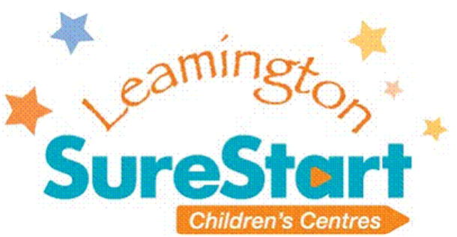  Leamington Spa  Breastfeeding Friendly Guide  June 2010

 |    . |  | 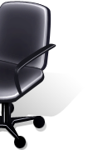 |  | 
 | Establishment (A-Z) | Address | Opportunity for privacy | Pushchair access | Change facilities
 | Arden’s | 98 Regent Street | No | Good | Change table in toilets
 | Bath Place at the Old Library | York Road | No | Good | Change table in toilets
 | Ben’s Cookies | 3, Satchwell Court | No | Good | No (near to Royal Priors facilities)
 | Boots the Chemists | Shires Retail Park, CV34 | Chair & curtain in baby change room | Good | Mother & Father rooms at rear
 | Café Nero | 72, Regent Street | Discreet areas towards back of café | Good | Change table in disabled toilet
 | Café Rouge | 95-99 Regent Street | Staff willing to move furniture | OK – 1 step | No
 | The Café Within (Wed-Sat only) | All Saints Church, Victoria Terrace | Corner tables or in play area within church | OK – 3 doors to get into cafe | Change table in disabled toilet
 | Costa Coffee | Royal Priors Shopping Centre | One area of seating is more discreet | Good | Change table in toilets
 | Druckers | Royal Priors Shopping Centre | No | Good | No (near to Royal Priors facilities)
 | Fat Birds | 95, Warwick Street | Discreet area behind serving area | Good | Change table in toilets
 | Five Rivers Indian Restaurant | 20-22, Victoria Terrace | Corner table or chair in staff room downstairs | OK - 2 small steps | Downstairs in Ladies toilet cubicle
 | House of Fraser | 76-86, The Parade | Chair in baby changing room | Wheelchair lift, ramp then lift | 1st floor via escalator or lift at rear
 | Jam | 102, Warwick Street | Certain tables have partial privacy | OK - 1 step | No
 | La Dolce | 42, Regent Street | Partial privacy in main area or upstairs if not busy | Good | No
 | Leamington Library  (& all Warwickshire Libraries) | Victoria Terrace | Staff direct women to comfy seat in a quiet area | Good | Baby change room near toilets
 | Linden Café | 19, Regent Street | No | Steps to get in & limited space | No
 | McDonalds | 34, The Parade | Office available or upstairs if empty | Good | Upstairs in Ladies Toilet
 | Mothercare | Shires Retail Park, CV34 | Excellent room with chairs opposite change room | Good | At rear of store
 | Newbold Comyn Leisure Centre | Newbold Terrace East | Family swimming changing room if not occupied | Good | Only in swimming changing rooms
 | Olive Garden Café | 5, Satchwell Court | No | Good | Change table in toilet
 | Paprika Club Indian Restaurant | 22, Regent Street | Private room upstairs | OK – 1 big step | No
 | Pizza express | 168, The Parade | Downstairs is private on weekdays | Assistance button due to 2 steps | Change table in toilet
 | Pizza hut | 140-142, The Parade | Certain booths have partial privacy | OK - heavy door | Ground floor in disabled toilet
 | Pump Rooms Tea Rooms | Victoria Terrace | No | Ramp on the right due to 4 steps | Baby change room near toilets
 | The Cotton Nappy company | 41 Russell Street | Lovely private feeding room | Good | Yes
 | The Restaurant in the Park | Jephson Gardens | No | Good | Yes in both Mens & Ladies Toilets
 | Royal Priors Shopping Centre | Lower Mall (near Druckers) | Excellent feeding room with comfy chairs & water | Good | Opposite feeding room
 | Seasons | 115, Warwick Street | Rear half of restaurant is partially screened off | OK - 1 step | No
 | Starbucks | Regents Court Shopping Centre | Discreet area towards back of café | Good | Change table in disabled toilet
 | Starbucks | Royal Priors Shopping Centre | Discreet area towards back of café | Good | Change table in toilets
 | Starbucks | Sainsburys, Shires Retail Park | Chair & curtain in Sainsbury’s baby changing room | Good | In Sainsbury’s
 | Strada | Regents Court Shopping Centre | Some high backed chairs | OK | Change table in disabled toilet
 | The White Horse | 4-6, Clarendon Avenue | Function room can be used if unoccupied | Good if through side door | Change table in disabled toilet
 | Zizzi | 85-87, The Parade | No | Good | Change table in disabled toilet
 | Please note that all information was correct at time of print. Details may change without prior notice.

