Tring and District NCT Nearly New Sale-Sellers Guide
Saturday 5th October 2019
10.00am-12.00pm
Desborough Hall, Tring School

You will need to register to receive your seller number. Please note, only 60 seller numbers are available.
1) Seller registration
- Each seller must register in order to receive a seller number
- Deadline for Registration is Friday 27th September 2019
- Registration costs £5 for 100 labels. For an additional 100 labels, there is a charge of £4 (restricted number available).
- To register, follow the instructions on the following link:
https://nct.intrabiz.co.uk/cgi-bin/sys.cgi?action=NCT-product-client_view&id=40173579

On completion of the registration process, you will then receive your seller labels in the post within ten days.

2) Commission and payment
- Any profits are split between the seller and the NCT
- Sellers retain 70%, and NCT retain 30% of the profits
- Sellers who also volunteer at the sale, retain 75% and NCT retain 25% of the profits
- Sellers will receive payment through BACS unless a seller has specifically requested a cheque payment during the registration process
3) Quality

- All items for sale must be clean, in good condition and full working order
- Toys should have no sharp edges, no toxic paint and should operate at less than 24 volts
- Goods that are stained, torn, damaged, bobbly, broken or incomplete are not suitable for sale
- Sellers need to ensure that their items have never been recalled. Lists and reports of such items can be found on the internet
- Stair gates, fireguards, bed guards and baby equipment with moving parts must have their correct fittings and instructions
- Tring and District NCT branch reserves the right to refuse the registration of any items that do not reach the quality requirements set out in these guidelines
- Should a buyer find fault with your items after the sale, Tring and District NCT branch reserves the right to deduct the sales value from your profit

Prams and pushchairs: We must comply with the law in respect of the sale of these items. This means that if you wish to sell a “wheeled child conveyance” then it must conform to British Standard 7409 (or an equivalent European standard) and must be permanently marked BS 7409:1966, together with the name or trademark of the manufacturer or importer. Instructions in English must be supplied with each vehicle, headed “IMPORTANT: KEEP FOR FUTURE REFERENCE” and must include instructions relating to the operation, assembly, use and maintenance. In addition, a permanent notice on the vehicle must state:

“Children should be harnessed in at all times and should never be left unattended. The child should be clear of moving parts while making adjustments. This vehicle requires regular maintenance by the user. Overloading, incorrect folding or the use of non-approved accessories may damage or break this vehicle. Read the instructions.”

4) Quantity
- Each seller can submit up to 100 items
5) Non-acceptable items
With regret we are unable to sell the following items:
- Recalled items
- Riding hats or crash helmets
- Bag style baby slings
- Car seats/car booster seats, ‘Isofix’ bases
- Mattresses without a waterproof cover
- Feeding bottles, baby food or formula milk
- Opened or past ‘use by date’ cosmetics
- Any items with a drawstring
Any of these items found will be removed and returned to you at the end of the sale.
6) Labelling your items
- All items must be labelled using the labels supplied – if labels are used from previous sales which are a different colour they won’t be calculated even if the goods are sold
- Both parts of the label must be completed, with the same information, for each item
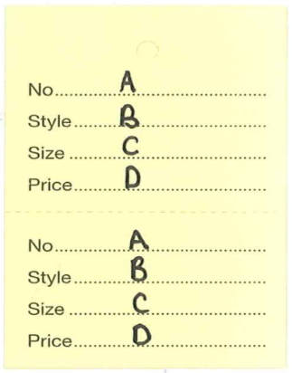
A = Seller’s number and name
B = Description
C = Age band or category from the list on the next page
D = Price

Below are some examples:
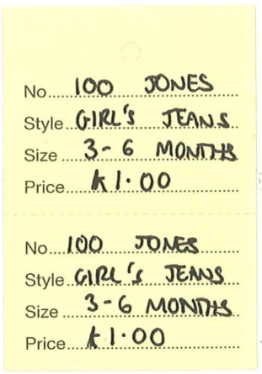
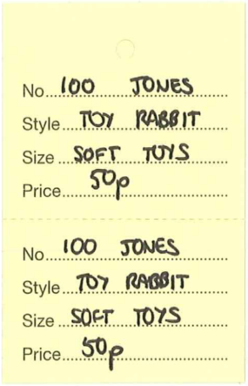
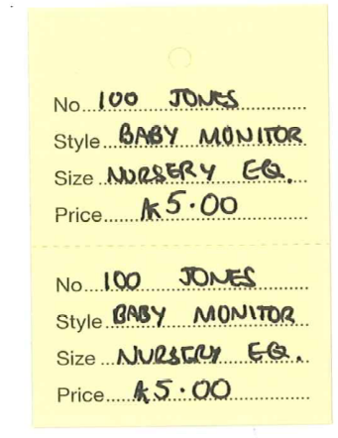

Use the following categories to label your items (choose the one from the grid below that is closest to your item description).
Large toys / Prams |  | Clothes (use sizes below)
Baby toys |  | 0-3 months
Toys for under 3’s |  | 3-6 months
Toys for over 3’s |  | 6-9 months
Nursery equipment |  | 9-12 months
Books |  | 1-2 years
DVD’s (no pirated copies) |  | 2-3 years
Jigsaw / Games |  | 3-4 years
Coats |  | 4-5 years
Shoes / Wellies |  | 5-6 years
Maternity Wear |  | 6-7 years
Fancy Dress |  | Swimwear

Important things to remember!
- Write your name AND seller number on each label
- If possible, use a coloured pen to write your labels (this helps with the sorting)
- Fix only the top part of the label to the item, as the bottom part needs to be removed when the item is sold
- Attach labels to clothes using safety pins or stitches, and to toys/equipment using masking tape or scotch tape
- Only one item per label. If you wish to sell something as a set-such as outfit, you must attach the items together securely so they are seen as one item
- Items to be sold together (such as Moses basket and stand) should be joined securely. Please add your name and seller number to all detachable parts, and label clearly that they are to be sold with the main item
- Unlabelled items, or those where the label has come off, cannot be sold
- Any unclaimed items at the end of the sale will be retained for one week-then donated to charity

7) Displaying your items
- All clothes must be freshly washed and ironed
- Items to be hung, such as clothes and sleeping bags need to be on hangers. Hangers can not be provided so don’t forget them
- Toys and equipment should be clean
- Remember-the nicer they look, the easier they will sell!

8) Pricing
- You choose your price, so consider what is a fair price to ask for the item
- Minimum price per item is 50p
- Price in multiples of 10p only, e.g. £2.00, £5.30, £7.10
Toys sell very well but remember to be realistic with your pricing. Items in their boxes will sell for more than those without. Any items with loose parts should attached securely, or if easier-place it all in a clear plastic bag. Cuddly toys and teddy bears do not tend to sell well.
Nursery equipment also sells well, at about 25%-50% of the standard price. Items sell for more, the more information is provided with them - so include any instructions or guarantees.
Clothing is perhaps the hardest to price. It must be in good condition, and will sell better if it is nicely presented and ‘in season’. Hand-knitted items do not sell well.
Generally, we have found that clothes are becoming far harder to sell, so you need to be realistic when you price an item. Ask yourself: Would I buy it? How much would I pay for it? Do I ever want to see it again?

9) The day of the sale
- Bring all the items you wish to sell, to the hall for 8:45 am
- On arrival, please report to the seller’s coordinator so you can be checked off the list and confirm if you want to return to collect unsold items or donate them to charity. All cot’s and moses baskets must be picked up as we are unable to donate these to charity.
- Tables and hanging rails will be clearly marked according to the categories
- Display your items in the appropriate areas and leave by 9:30 am
- Take any storage boxes and bags with you as we are unable to store these
- Return to collect any unsold items between 12:30 pm and 1:00 pm
10) Unsold goods
- Unsold items must be collected between 12:30 and 1:00 pm unless you have told us at seller check in to donate all of your unsold items
- You will not be allowed access to the hall before this
- Please take all your unsold items away with you; we have no storage for such items
- Any unclaimed items at 1:00 pm will be taken to charity – please inform us if you will not be collecting your items
- Remember to look in the ‘unlabelled’ or ‘unsuitable’ boxes in case any of your items have been placed in there
11) Disclaimer
The NCT cannot be held responsible, or expected to make up the value for any items lost, stolen or damaged at the sale-although we will make every effort to prevent this.
Please note, the following disclaimer will be displayed at all tills: The National Childbirth Trust (NCT) cannot be held liable for any loss or damage arising from the goods purchased. The goods for sale are second-hand goods and will not be to the standard of new items. Customers should inspect all goods, as we are unable to accept return items. The NCT cannot be held responsible for any items left unattended at the venue following purchase. Such items are left at the purchaser’s risk.

12) Help on the day
The sale is run by volunteers, so if you can help, please do! Remember, volunteers get first pick of items at the sale, and also receive a reduction in seller’s fees. We need help with:
- Set-up of the Hall
- Quality control checks prior to the sale
- Helping sellers to display items correctly
- Running the tills during the sale
- Tidying and clearing at the end of the sale
- Email TringAndDistrict@nct.org.uk to find out more or register yourself to help

13) Advertising
We do put posters up to advertise these events, but we rely greatly on our sellers to help publicise them via word of mouth too, so please tell your friends and family about the sale. If you are able to display posters, or distribute some flyers-please email TringAndDistrict@nct.org.uk or make a note on your application form and we will send you some with your labels.
You can help to publicise the sales, especially at any baby and toddler groups you might attend - so tell any new and expectant parents about all the fantastic bargains!
We also offer the chance for local businesses to advertise by placing a leaflet in the goody bags we hand out to all buyers at the sale. If you know of someone that would like to advertise their business in this way they can find all instructions and links for payment at the link below:
https://nct.intrabiz.co.uk/cgi-bin/sys.cgi?action=NCT-product-client_view&id=40335930

Checklist
- Do you know your seller number?
- Have you got your labels?
- Do you know what you can and cannot sell?
- Do you know how many items you can sell?
- Have you checked that all your items and in good condition, are clean and are working?
- Have you put all your hung items on hangers?
- Have you used the labels provided, and written the information required on both parts?
- Are the top of the labels attached with safety pins or stitches on clothes, and with masking/scotch tape on everything else?
- Do you know where to take items and when?
- Have you arranged to collect any unsold items?

If you are unsure about anything, please email TringAndDistrict@nct.org.uk and we will be happy to help ☺

