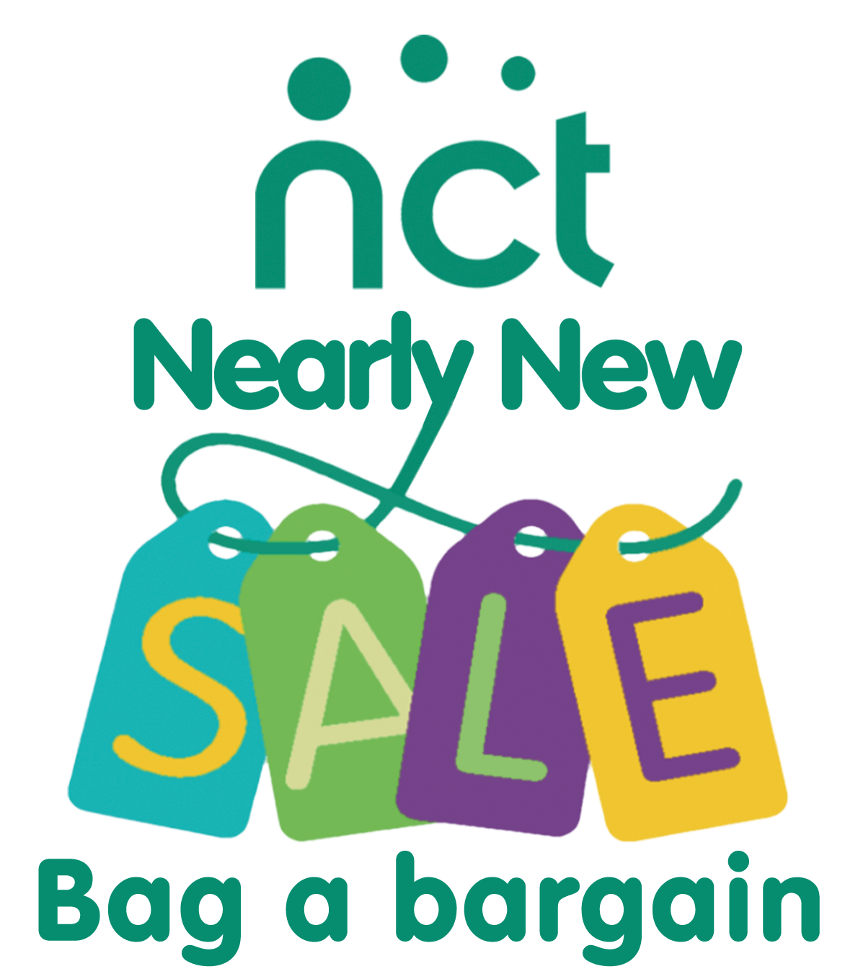

Harrogate and District Branch

NCT Nearly New Sale

Seller’s Pack

Thank you for signing up to sell at our next NCT Nearly New Sale. Our sale is a great way of raising awareness and funds for the work of the charity. To ensure that the sale runs smoothly, please read through this guidance.

1. Venue
Harrogate High School, Ainsty Road, HG1 4AP

The sale will be clearly sign-posted from Skipton Road. Once you turn onto Claro road, it is a right turn onto Ainsty Road, and the High School is straight ahead of you. Please follow the sellers’ signs. There is a sellers car park at the rear of the school.

2. Times

Drop off items 10:30 – 11:00
NCT members shop from 12:40
Sale time 13:00 – 14:30
Pick up items 16:00– 16:30

More details are shown in sections 9 ‘Morning of the sale’ and section 10 ‘After the sale’.

3. Seller Registration Number
• Your seller number is unique to you and was given when you registered.
• Your seller number must be used on all correspondence and on all item labels.

4. Items you can & cannot sell
We sell maternity goods, parenting goods, baby and children’s clothing, toys, books and equipment. We would not recommend selling items for children over the age of 10.

There are a few items we cannot sell, and some restrictions. These are listed in our Nearly New Sale Principles on our national website. All sellers MUST read and abide by our Nearly New Sale Principles.
https://www.nct.org.uk/get-involved/fundraising-activities/nct-nearly-new-sales/sell-nearly-new-sales

In addition to the Sale Principles, Harrogate & District NCT will not be accepting the following items:

- Second hand mattresses from cots, cribs or Moses baskets without a waterproof cover.
- Pedal Cycles with a saddle height over 635mm.
- Mains powered electrical equipment or toys, even if these also run on batteries (this includes sterilizers, breast pumps and baby monitors).
All items will be checked, any items not following these rules will be rejected.

5. Labelling
• Every item you bring to the sale must have one of our NCT Harrogate branch labels securely attached.
• You will find a link to the labels template on your seller’s invitation email or on our webpage at:
https://www.nct.org.uk/local-activities-meets-ups/region-yorkshire-humber/harrogate-district
• Enter your seller number on the first tab, where indicated, and print off as many labels of each size as you need.
• Do not use labels supplied for previous sales as these are not in the correct format or have the correct number.
• Ensure that each ticket is complete to include part A & part B, any items without a complete ticket will be rejected.
• Each label must show your seller number, description of item, size and price.
• Part A of the label must be attached firmly to the item.
• Clothing items must be labelled with a safety pin. Please do not use dress making pins or staples, any items with such pins or staples will be rejected.
• Part B will be detached by scissors at the till and returned to you in your envelope within 4 weeks of the sale.
• Please do not tape or glue part B.
• For security reasons, altered labels will not be processed at the tills, so if you need to alter a price, please re-label the item.

If you are selling a baby sling or carrier, please also print and attach this additional label. It will not be sold without one.
https://www.nct.org.uk/sites/default/files/related_documents/Note%20to%20be%20attached%20to%20any%20sling%20being%20sold.pdf

Please note:
Every effort is made to ensure security at the sale. However, the NCT cannot accept responsibility for items that are lost, damaged or stolen and no compensatory payment will be made. Careful and secure labelling minimises the risk of losses.

5. Sorting Items
• Items of clothing must be sorted by age group age (Maternity, 0-3 months, 3-6 months, 6-12 months, 1-2 years, 2-3 years, 3-4 years, etc and by sex). If possible please put them in separate bags/boxes prior to drop-off to help sorting and display.
• Clothes can be placed on hangers as these sell well, however space is limited. We have plenty of space for rummage items and if these are labelled clearly will also sell well.

6. Pricing
• Minimum price 50p, increasing in multiples of 50p (e.g. 50p, £1.00, £1.50)
• You can group items together to reach this minimum. We generally recommend a price of approximately a third of the original retail value.
• Items priced under 50p will be treated as a donation to the NCT, items not in multiples of 50p will be rounded down.

Suggested Price guide
Please think about how much YOU would be prepared to pay and aim to be realistic in pricing. If you are desperate to be rid of an item, price competitively.

Babygros
£0.50-£1.00
Maternity dress £4.00 - £12.00
Single pushchair £10.00 - £75.00
Trousers
£1.50 – £2.50
Maternity trousers £3.00 - £8.00
Double pushchair £40.00 - £120.00
Coats
£3.00 - £7.00
Jigsaws/Games £0.50 - £3.00
Travel system/pram £40.00 - £250.00
Dresses
£2.00 – £6.00
Cot (no mattress) £10.00 - £40.00
Booster seat
£3.00 - £8.00

7. Maintaining Quality
We will continue with quality checks on all items. Sellers will drop off items in sorted bags or boxes and the volunteers will be checking and displaying all the items. Please ensure that any item you sell is of a good quality and in working order. If not, they will be rejected.

• NCT Nearly New Sales have a reputation for selling high quality items and we attract a high volume of buyers who are prepared to pay reasonable prices.
• All items will be checked before the sale and items that are not considered ‘nearly new’ or do not adhere to our terms and conditions (e.g. safety) will be rejected. These can be collected by the seller from the reject table at the end of the sale.
• Clothing and equipment must be in good condition and working order. Toys sell better with batteries. Shoes sell better in boxes.
• Please put special clothes on hangers, e.g. party frocks, dressing up item etc.
• If an item came with instructions, where possible, these should be attached.
• A significant amount of clothing is left unsold at the end of the sales, so we recommend that you only sell best quality, seasonal items.

8. Seller’s Envelope
This will now be provided for you and is part of the registration fee.

9. Morning of the sale – dropping off your sale items
• Please ensure you follow signs for NCT NNS Sellers drop-off zone.
• Please bring your items to the venue between 10:30 and 11:00 (unless you are a volunteer helper arriving earlier – see below).
• There will be NO ACCESS for sellers after 11:00
• Ensure you sign in on arrival.
• Take your goods into the hall and drop off at each section. DO NOT PUT YOUR ITEMS OUT FOR SALE, AS THEY NEED TO BE QUALITY CHECKED. Take any bags and boxes that you wish to keep away with you.

10. After the sale – collecting your unsold items
Our volunteers will be sorting all items at the end of the sale, so that sellers will be able to locate their items quickly. Please collect your unsold items between 16:00 and 16:30.

Please note that no charities will be collecting items at the end of the sale and all items need to be taken. Any sellers that do not collect their items are subject to a £5 charge to arrange removal and disposal of their items.

11. After the sale – payment for sold items
• Within 3 weeks of the sale the money for your items will be transferred to your bank account by BACS payment.
• If you haven’t received your BACS payment within this time frame please contact us.
• You will be paid 70% of the value of your sold items.
• The NCT receives 30% of the sale price as commission.
• If you have helped at the sale as a volunteer and have stayed from 10:00 to 16:30 the NCT will only receive 20% commission from your sales – so you get to keep 80%.
• All commission received goes towards funding the services that the NCT provide in the Harrogate & District area as well as across the UK.

12. Volunteering
• We need lots of volunteers to help on the day of the sale– from section heads to working the tills, keeping the sections tidy, or running the money. It is a fun day, and a chance to work on one of the most successful NCT sales in the UK. Join us!
• All volunteers are allocated time to shop before anyone else. Volunteers who are also sellers and able to help between 10:00 to 16:30 will benefit from a reduced NCT commission rate of 20%.
• NO CHILDREN under 10 years, except babies in carriers, can accompany volunteering parents at the sale. Any volunteers that arrive at the sale with children will be asked to leave. This is for everyone’s safety.
• Please let us know as soon as possible or at least 2 weeks before the sale if you would like to volunteer.

13. Refreshments
We provide free bottles of water and biscuits for volunteers at the office. If you are volunteering we recommend that you bring lunch with you. No food can be consumed in the Sports Hall.

14. Publicity
If you would like posters for the sale to pass on to friends, playgroups or nurseries, then please contact us by email or through the Facebook page (Harrogate and District NCT). Also please tell everyone you know about the sale as without buyers we don’t make many sales!

15. Disclaimer
Every effort is made to ensure security at the sale. However, the NCT cannot accept responsibility for items that are lost, damaged or stolen and no compensatory payment will be made. Careful and secure labelling will minimises the risk of losses.

16. Contact Us
Email: NNS.Harrogate@nct.org.uk
Web: https://www.nct.org.uk/local-activities-meet-ups/region-yorkshire-humber/harrogate-district

Thank you for taking the time to read and follow these instructions.
We hope you, and the NCT, have a successful sale.

