SELLERS PACK

Date: Saturday 7th October 2017

Venue: Leehurst Swan School, Salisbury SP1 3BQ

Drop off items: 0800-0830

NNS Volunteers pre-sale: 0915

NCT Members admission: 1000

Public admission: 1015

Doors Close: 1200

Collect unsold items: 1300-1330
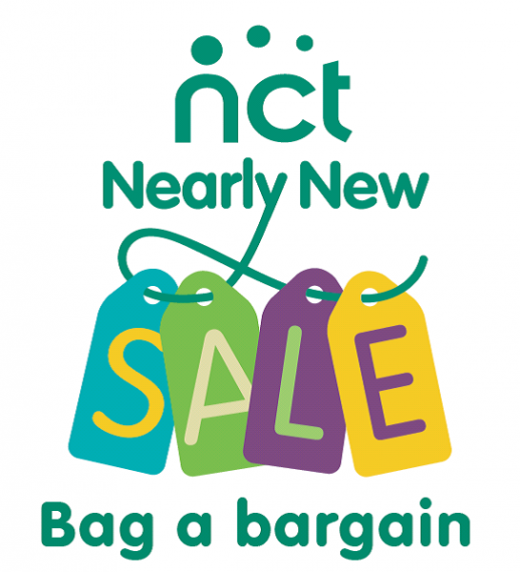

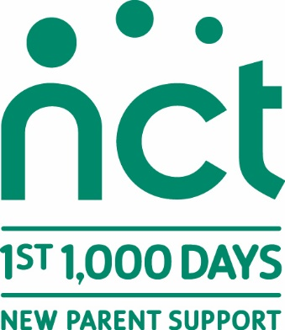
Thank you for signing up to sell at our next NCT Nearly New Sale. Our sale is a great way of raising awareness and funds for the excellent work of NCT - our last sale generated over £4,000.

To ensure that the sale runs smoothly please read through the simple guidelines in this leaflet. Please arrive to drop of your items at 0800. You can collect your items from 1300 until 1330. Any uncollected items will be subject to a £5 seller fee.

If you have any questions or need any more information then please contact the Nearly New Sale team on nns.salisbury@nct.org.uk. The sale is run entirely by volunteers so don’t worry if you don’t hear from us straight away, we will get back to you.

What can I sell?
Clean, good quality and correctly labelled items such as baby & children’s clothes, children’s toys & equipment and books can all be sold. Clothing is seasonal so you may find the relevant clothing for autumn/winter or spring/summer sells better. Please see below for items which are accepted at NCT Nearly New Sales.

The following items can be sold, provided they meet the requirements:
• Children’s Toys (if safe, complete and in good working order)
• Clean, dry and firm second hand mattresses (must have a waterproof cover with no tears, crack or holes). ‘Ventilated’ mattresses should not be sold
• Children’s pedal cycles (saddle height less than 635mm)
• Prams & Buggies which meet the checklist criteria;
Must meet the requirements of the Wheeled Child Conveyances (Safety) regulations 1997.
Must have a permanent label (usually on the frame or seat cover) stating compliance with British Standard 7409 or EN1888. The standard lays down requirements regarding the construction, performance and labelling for prams & pushchairs. Machines must also have a label headed ‘Carelessness Causes Fire’ which indicates that the fabric complies with flammability requirements.
In addition, prams and buggies should be checked for the following;
Brakes – these should work and be able to stop a loaded machine on a slope. The tyres should also be examined as these can affect the performance of brakes.
Locking devices – there should be two locking devices on each machine so that when the main lock is released, the secondary lock prevents the frame from collapsing.
Harness – a secure harness must be fitted.
General – look for damage from wear and tear. Check to ensure that a child’s fingers cannot be caught anywhere. The frame should be secure and free from sharp edges or exposed parts.
• Upholstered furniture, including cots and highchairs, with the permanent label “Carelessness Causes Fire”
• Cosmetics if unopened, originally for sale in the UK and before their use by date
• Carrycot stands labelled with size and weight loadings. Must have a guard rail, suitable base and be a maximum height of 432mm. Please supply instructions
• Brand new, manual breast pumps with bottles.

This is a Nearly New Sale - if items are in poor condition they will put buyers off and we reserve the right not to include them in the Sale and return them to your bag.

How much money can I keep?
For all the items that you sell you will take home 70% of the sale price. NCT takes a 30% commission which goes towards the charity’s work supporting local mums and dads, preparing them for birth and early parenthood. The exception to this is if you volunteer for the duration of the NNS (0700 – 1400, see further details below), in this instance your commission will be reduced to 20% as a thank you for your help.

What cannot be sold?
It is your responsibility to ensure that goods you are selling are safe and fit for purpose. In order to protect NCT, you (the seller) and our customers, we have created a list of items that WILL NOT be accepted for sale at any NCT Nearly New Sale:
• Recalled items (see information about recalls on RAPEX: http://ec.europa.eu/consumers/dyna/rapex/rapex_archives_en.cfm )
• Bag style baby slings
• Car seats, car booster seats, ’Isofix’ bases or car seats from travel systems
- Mains powered electrical equipment or toys
• Riding hats or crash helmets
• Children’s outer garments with a draw string hood
• Bottles, baby food & formula milk
• Second-hand breast pumps

How much can I sell?
The registration fee of £3 allows you to sell 70 items. If you wish to sell more you can buy ‘add on’s’ when registering, allowing for an additional 70 items costing £1 per add on. Each seller must complete their ‘Sellers List/s’ and submit this when delivering items for sale on the sale day.
How should I prepare & price my items?
• Please price items in multiples of 50p. (£1.00, £1.50, £2.00 etc.)
• The minimum price is £1.00. Anything priced below £1.00 (i.e. 50p) will be considered a donation to the NCT.
• Pricing is up to you but bear in mind that if you price things highly they may not sell. Many high street outlets are selling clothing very cheaply now, even quality brands, so price your items competitively.
• As a very rough guide items sell between one third and one half of their original price depending on condition. Most sellers use the following guidelines:
Babygros – £1 to £2 Cardigan/Jumpers - £1 to £3
Coats/Jackets - £2 to £5 Dresses - £2 to £5
Trousers/Jeans - £1 to £4 Shoes/Wellies - £1 to £3

How should I label my items?
We use a two part label system to increase accuracy and speed up payment at the tills. At the checkout, half the label will be cut off and retained and half will remain attached to the item. Please use the labels provided in this document OR on the Excel spreadsheet also attached to the email (‘NNS labels auto fill’) to mark up your goods before the sale.
ATTACH TO ITEM
Description

Item no. | Seller no.
Price £

REMOVE AT TILL
Description

Age/Size
Item No. | Seller No.
Price £

Both halves of the label should display the same information. Please attach just one half of the label to your items - the other half needs to be easily removed at the tills. Labels need to be attached securely to items (not to hangers) using safety pins or tape. For security reasons we do not sell items without a label attached. So no label = no sale and the item can only be returned to you if you pick it from the “lost labels” table at the end of the sale.
E.g.

This section stays on the item

This section to be removed by cashier at till – don’t secure this section to item please

Included in this document is a sellers list & a sheet of labels which you MUST use. The details are used for accounting purposes and to ensure that you receive the right payment for your sold goods. PLEASE ENSURE YOU WRITE YOUR SELLERS NUMBER CLEARLY & IN RED ON YOUR LABELS. Please take care that all the details on the label match those on your Sellers List of Items for Sale. Please also take care not to mix up your sellers number with the item number.

How should I package my items?
• Bring your items in a bag(s) that you will leave with the volunteers at the reception desk.
• We recommend that all clothing is put on hangers as it is easier to display than in bags. If selling a bundle of items please ensure they are firmly attached to each other and that the price tag states clearly what is included in the bundle.
• If your item contains detachable pieces, eg. equipment or toys, then be sure they are attached firmly to the item so they cannot be lost.
• If you have the original packaging and or instructions please include them - but don't tape it shut as people who can't check the goods inside may be reluctant to buy it.

What are the drop-off arrangements?
- You are required to ‘sign in’ sale items between 0800-0830 on the day of the sale.
- Together with the sale items you must include your ‘Sellers List of Items for Sale’ and an empty black bin bag labelled (A4 size) with your sellers number.
- We ask that sellers assemble larger items themselves, if required.
- Please ensure that your goods can be dropped off quickly – this is a very busy time! Please also ensure you park legally and considerately.

What happens after the sale?
• After the sale your items will be sorted into the numbered bin bag you have provided and will be available for you to collect at 1300. Make sure that you also check the lost property table.
• Please note that, whilst we do our best to provide reasonable security at sales, all items are left at the venue at the seller’s risk. NCT accepts no liability for any loss or damage caused to goods for sale.
- At registration you were able to opt for payment by BACS. These are normally sent on the Friday after the sale and arrive in your bank account on the following Tuesday. We cannot guarantee the arrival of cheques, but they will usually take longer to arrive than BACS payments – please note that cheques are now only issued via NCT UK Office NOT the branch.

Volunteering
• The success of our Nearly New Sales depends entirely on our fantastic team of volunteers
• We always welcome new members of the team and there are a number of different roles available. To thank you for your efforts all volunteers are invited to join in the presale shopping before the doors are open to the public. Volunteers who help out for the duration (0700-1400) and are also sellers are entitled to a discounted commission rate of 20%.
• To register to volunteer click this link;
https://nct.intrabiz.co.uk/cgi-bin/sys.cgi?action=NCT-product-client_view&id=33355258
Any other questions please email the NNS Coordinator Jo Woodman via nns.salisbury@nct.org.uk.

Our next sale will take place on Saturday 7th October 2017. We hope to see you there.

NCT Salisbury & South Wiltshire NNS – Seller’s List of Items of Sale

Seller’s Name……………………………………………….....Sellers Number

Item Number | Description | Age / Size | Price
1
2
3
4
5
6
7
8
9
10
11
12
13
14
15
16
17
18
19
20
21
22
23
24
25
26
27
28
29
30
31
32
33
34
35
36
37
38
39
40
41
42
43
44
45
46
47
48
49
50
51
52
53
54
55
56
57
58
59
60
61
62
63
64
65
66
67
68
69
70

REMINDER CHECKLIST
- Is your seller number clearly marked in RED on your labels & have you completed ALL parts of the label?
- Have you completed your List of Items for Sale & kept a copy for yourself?
- Are labels on clothes fastened securely? (using safety pins or string please)
- Are labels on toys / equipment attached by sellotape or masking tape?
- Have you provided an empty black bin bag labelled clearly (A4 sized) with your sellers number?

**Extra list for add on’s**
NCT Salisbury & South Wiltshire NNS – Seller’s List of Items of Sale

Seller’s Name……………………………………………….....Sellers Number

Item Number | Description | Age / Size | Price
ATTACH TO ITEM |  |  |  |  | ATTACH TO ITEM |  |  | ATTACH TO ITEM
Description |  |  |  |  | Description |  |  | Description
Item no. | Seller no. |  |  |  | Item no. | Seller no. |  | Item no. | Seller no.
Price £ |  |  |  |  | Price £ |  |  | Price £
REMOVE AT TILL |  |  |  |  | REMOVE AT TILL |  |  | REMOVE AT TILL
Description  Age/Size |  |  |  |  | Description  Age/Size |  |  | Description  Age/Size
Item No. | Seller No. |  |  |  | Item No. | Seller No. |  | Item No. | Seller No.
Price £ |  |  |  |  | Price £ |  |  | Price £
ATTACH TO ITEM |  |  |  |  | ATTACH TO ITEM |  |  | ATTACH TO ITEM
Description |  |  |  |  | Description |  |  | Description
Item no. |  | Seller no. |  |  | Item no. | Seller no. |  | Item no. | Seller no.
Price £ |  |  |  |  | Price £ |  |  | Price £
REMOVE AT TILL |  |  |  |  | REMOVE AT TILL |  |  | REMOVE AT TILL
Description  Age/Size |  |  |  |  | Description  Age/Size |  |  | Description  Age/Size
Item No. |  |  | Seller No. |  | Item No. | Seller No. |  | Item No. | Seller No.
Price £ |  |  |  |  | Price £ |  |  | Price £
ATTACH TO ITEM |  |  |  |  | ATTACH TO ITEM |  |  | ATTACH TO ITEM
Description |  |  |  |  | Description |  |  | Description
Item no. |  | Seller no. |  |  | Item no. | Seller no. |  | Item no. | Seller no.
Price £ |  |  |  |  | Price £ |  |  | Price £
REMOVE AT TILL |  |  |  |  | REMOVE AT TILL |  |  | REMOVE AT TILL
Description  Age/Size |  |  |  |  | Description  Age/Size |  |  | Description  Age/Size
Item No. |  |  | Seller No. |  | Item No. | Seller No. |  | Item No. | Seller No.
Price £ |  |  |  |  | Price £ |  |  | Price £

